Signing Up:

1. Click on the blue button “Click here to Sign Up!” to be redirected to the sign up page.

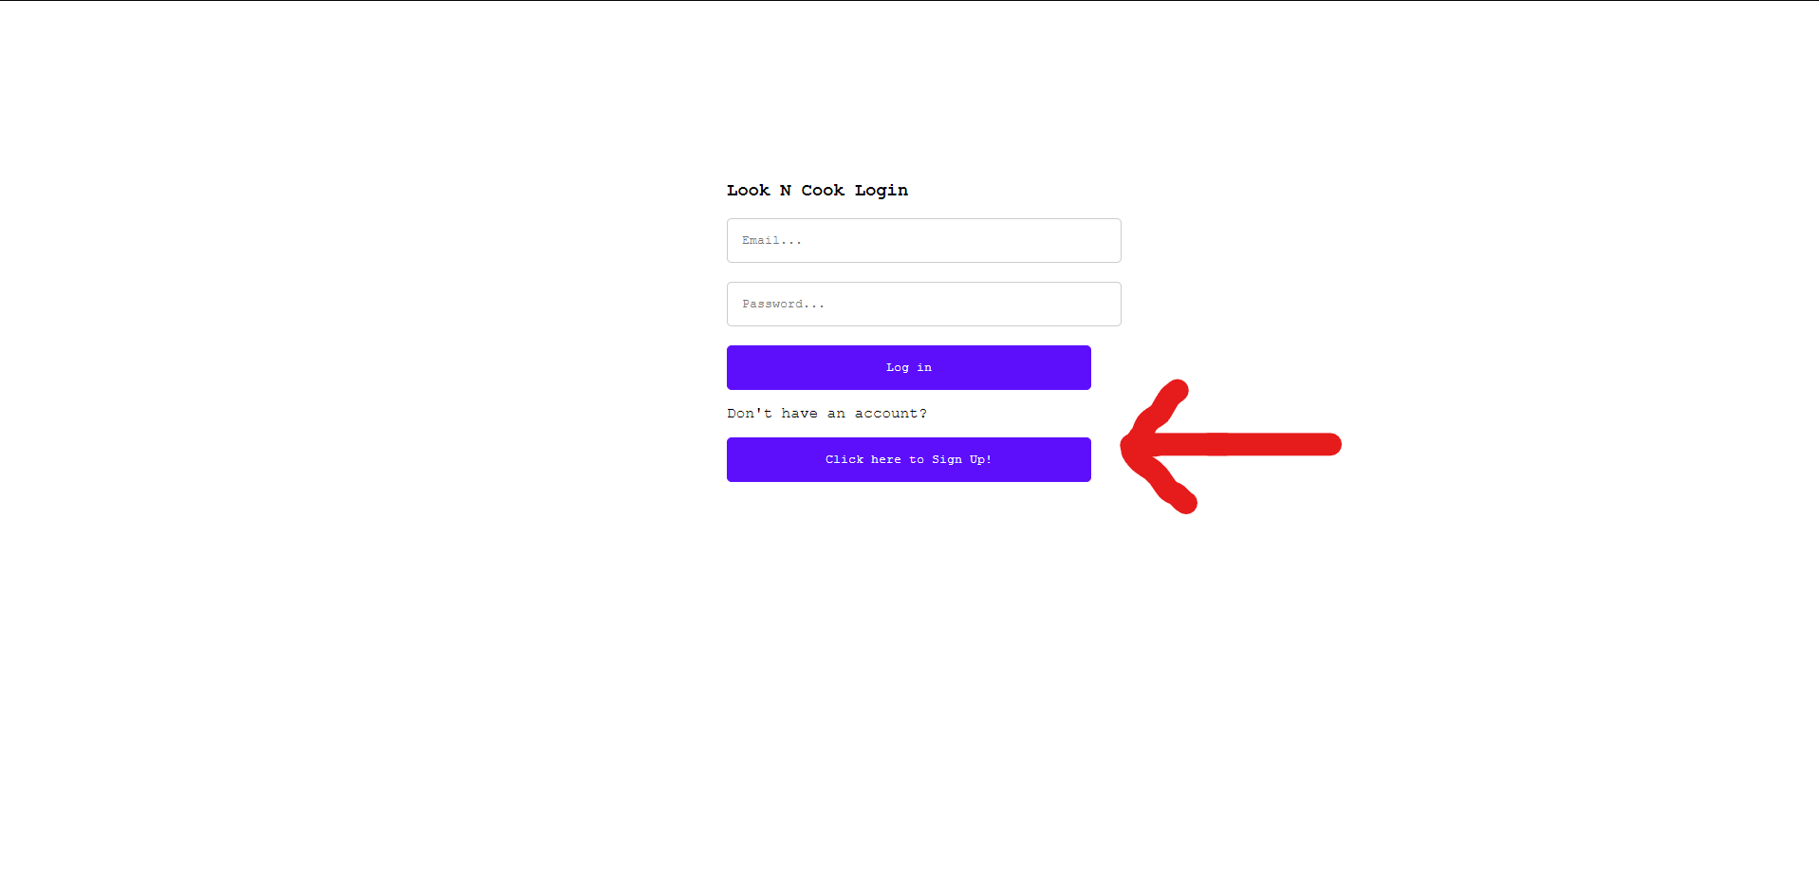

1. Enter your email and password to create your account.

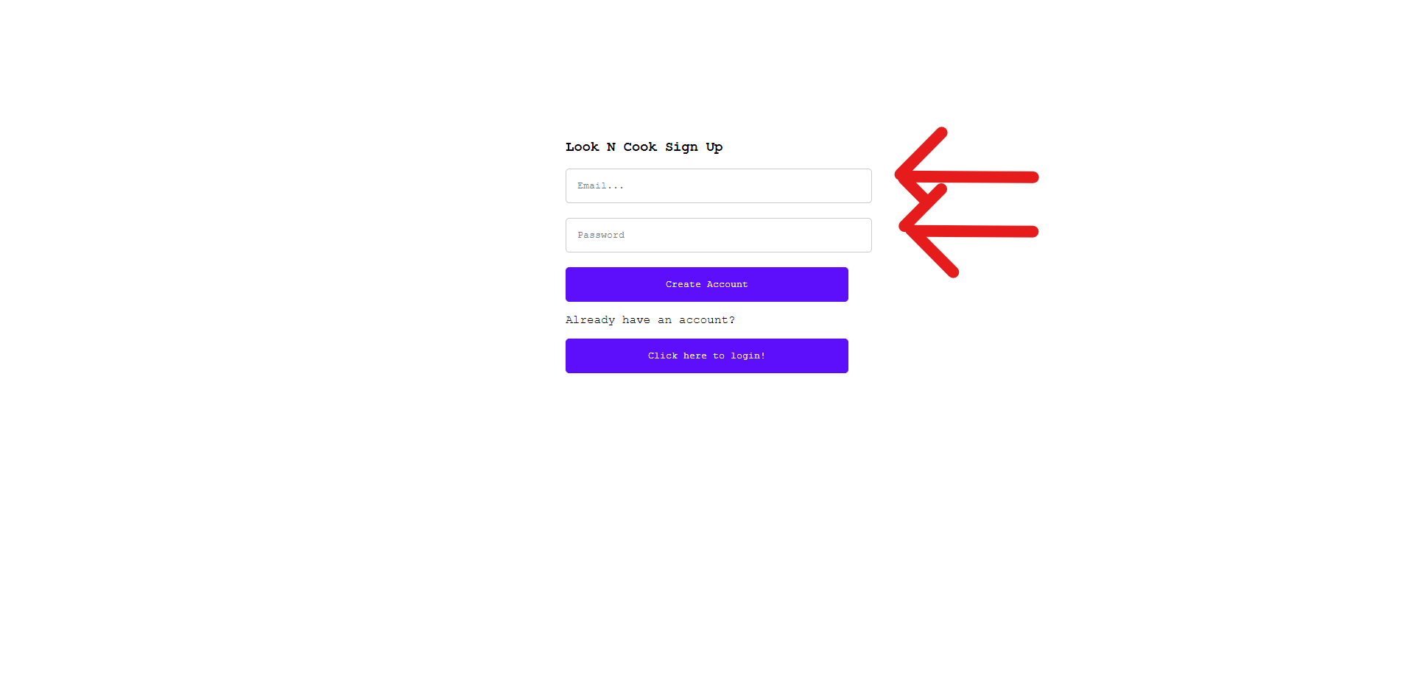

1. To continue click on the blue button “Create Account”.

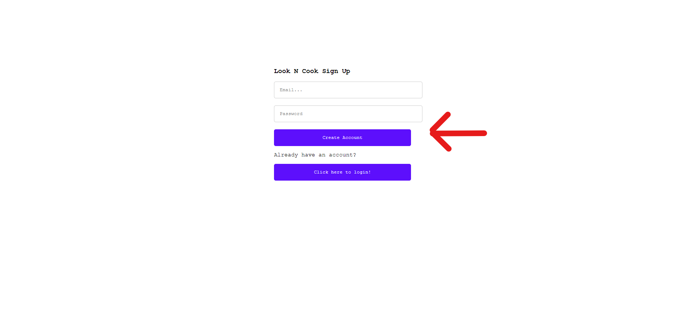

1. Welcome to the homepage!

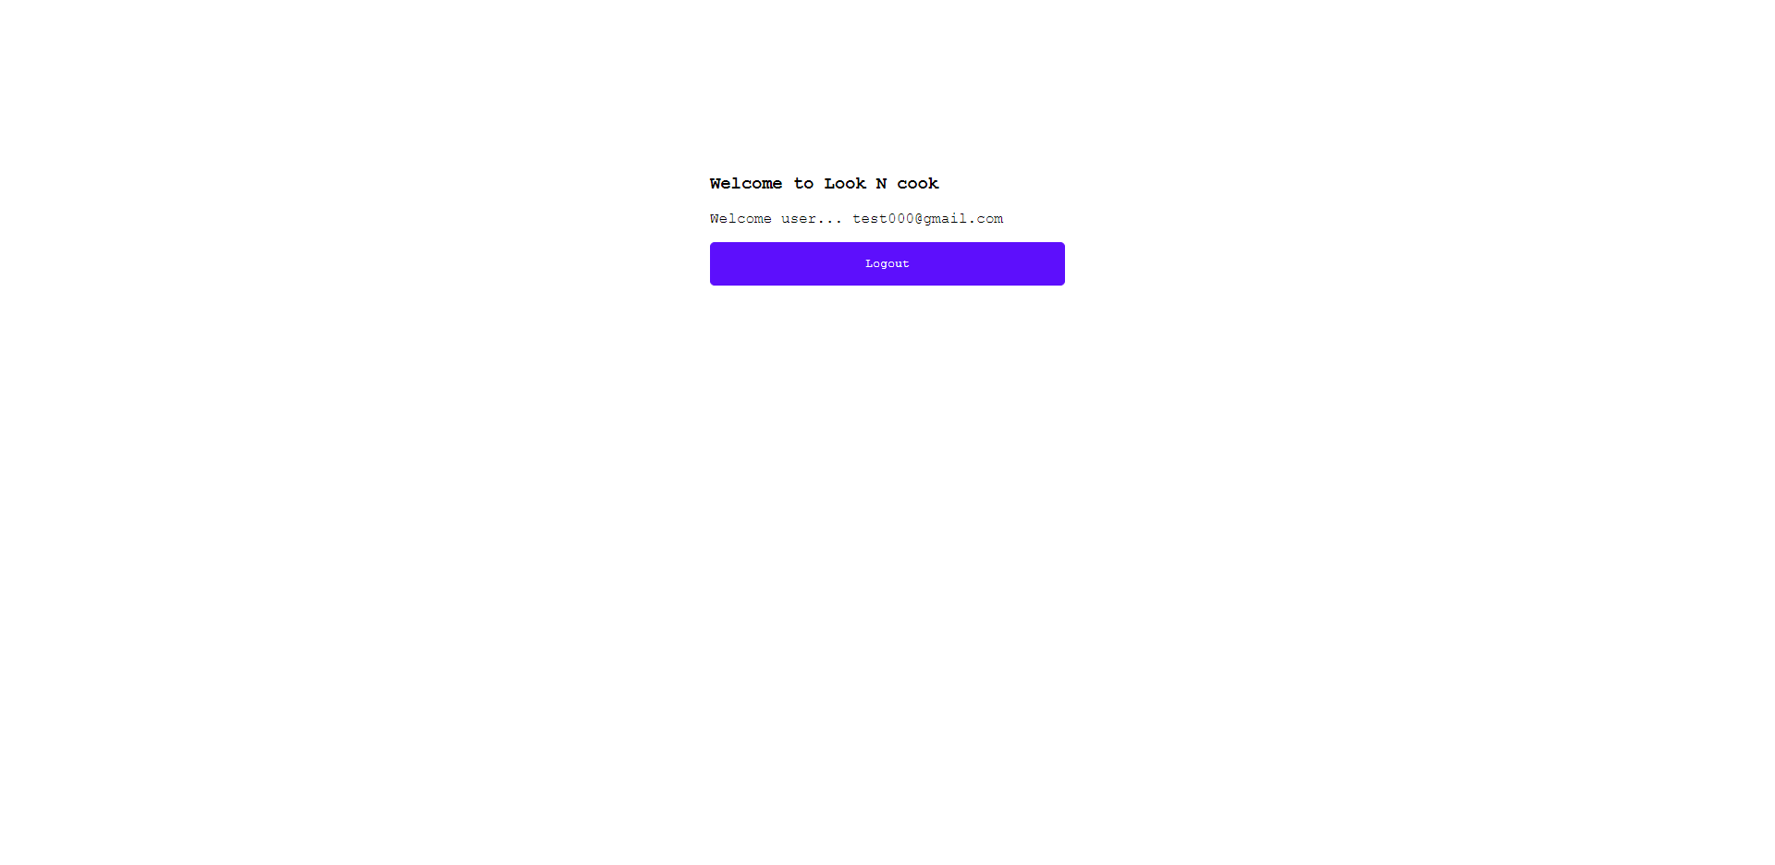

Logging In:

1. Enter your email and password.

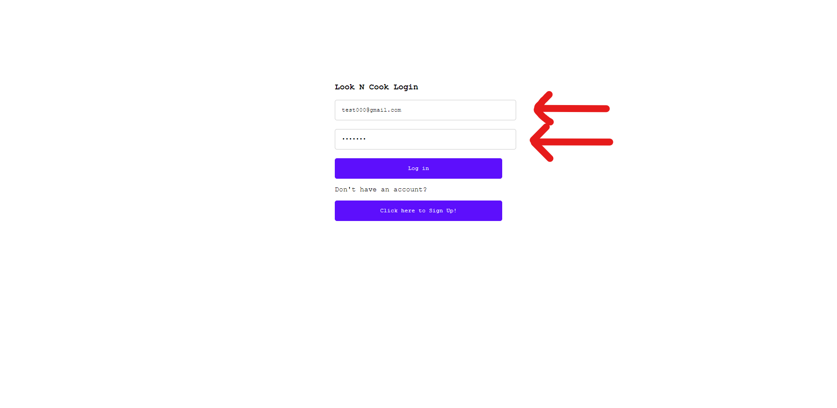

1. To continue click on the blue button “Log in”.

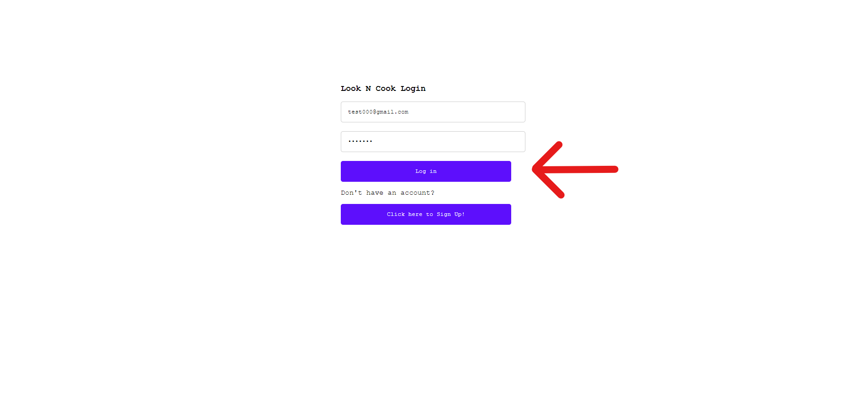

1. Welcome to the homepage!

